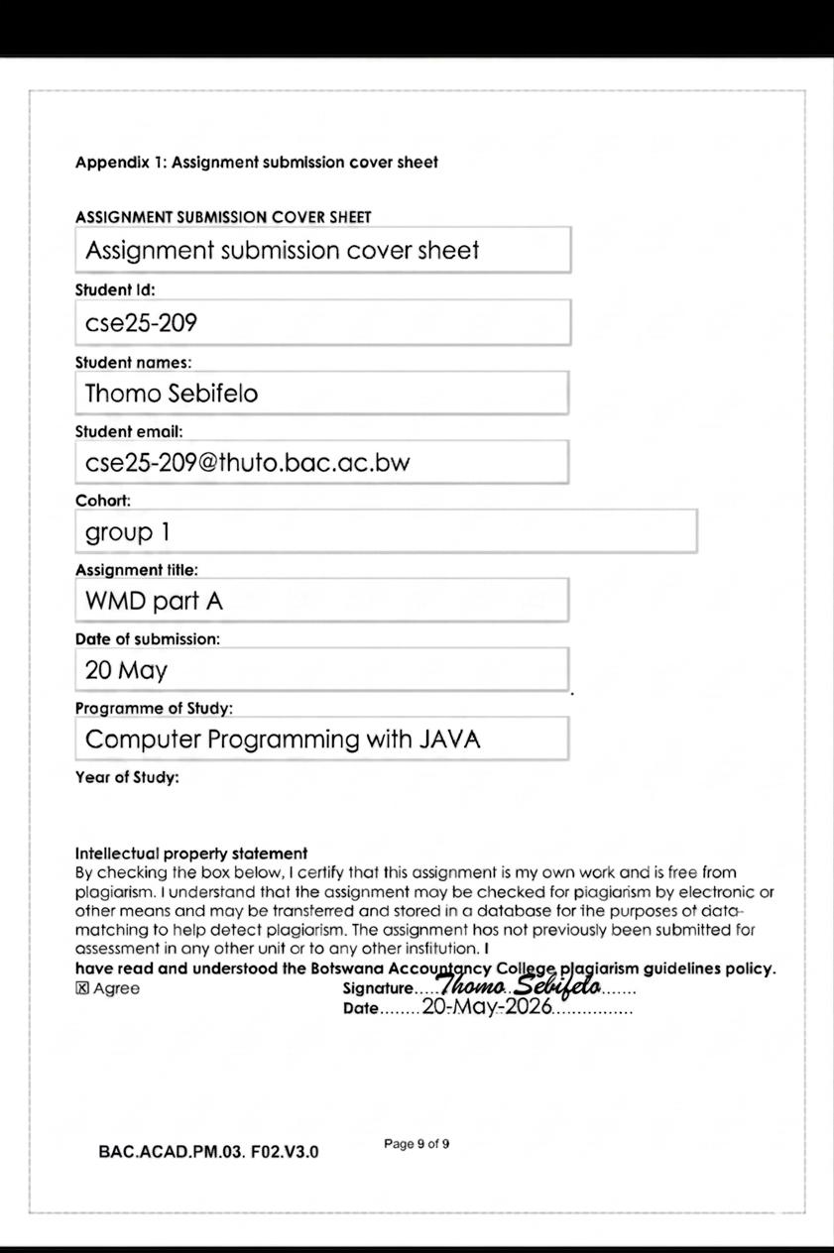
WMD part A (Bots Tech Gadgets )

INTRODUCTION
This report presents the planning, design and development documentation for the Bots Tech Gadgets website. Bots Tech Gadgets is an online technology gadgets store that sells laptops, smartphones, gaming accessories and headphones. The role of the website is to provide customers with a modern online platform where they can browse products, view prices, place orders and contact the business easily.
The website was designed using modern web technologies such as HTML5, CSS3 and JavaScript. The website was also designed to be responsive so that it works properly on desktops, tablets and mobile devices.

1. WEBSITE SPECIFICATIONS
a. Website Objectives
The objective of the Bots Tech Gadgets website is to create an online platform that advertises and sells electronic gadgets and accessories. The website allows customers to access information about available products and services at any time. The goals of the website include:
Increasing online sales of gadgets and accessories in the store, Promoting the Bots Tech Gadgets brand, Providing customers with product information and pricing, Improving communication between the store and customers, Expanding the number of customers through online marketing, Providing a simple and user-friendly shopping experience as customers do not need to visit the store physically.
b. Target Audience
The target audience for Bots Tech Gadgets includes, Teenagers and young adults, University and college students around Botswana, Gamers as well as Office workers
Demographics
Age group: 18–40 years
Gender: Male and Female all genders
Location: Botswana and surrounding regions
Income Level: Medium income earners and students

Technical Aptitude
The users are expected to have basic digital skills sets such as, Browsing and navigation of websites, using computers , filling online surveys or documents and using online shopping platforms or websites.
c. Type of Website
Bots Tech Gadgets is an E-commerce Website because it allows users to browse and purchase products on a website online. The website content includes Product information , images of the product , it’s prices, contacts of the store, customer feedback space and a shopping cart . The website focuses on selling laptops, smartphones, gaming accessories and headphones specifically.

2. INFORMATION DESIGN & TAXONOMY
Information Architecture
The information architecture organizes the content into categories for easy access and navigation.
Main Navigation Structure
Home
Products
Laptops
Phones
Gaming Accessories
Headphones
About Us
Contact Us
Cart
Feedback
This structure ensures that users can access products within three clicks as recommended in website usability standards.
Site Map
Plain text
Home Page
│
├── Products
| ├── Laptops
| ├── Phones
| ├── Gaming Accessories
| └── Headphones
│
├── About Us
│
├── Contact Us
│
├── Cart
│
└── Feedback Form

Storyboard Flowchart
Plain text
User Opens Website
↓
Home Page
↓
Select Product Category
↓
View Product Details
↓
Add Product to Cart
↓
Proceed to Checkout
↓
Submit Feedback / Contact
The storyboard demonstrates how users navigate the website .

3. PAGE TEMPLATE DESIGN
Wireframe
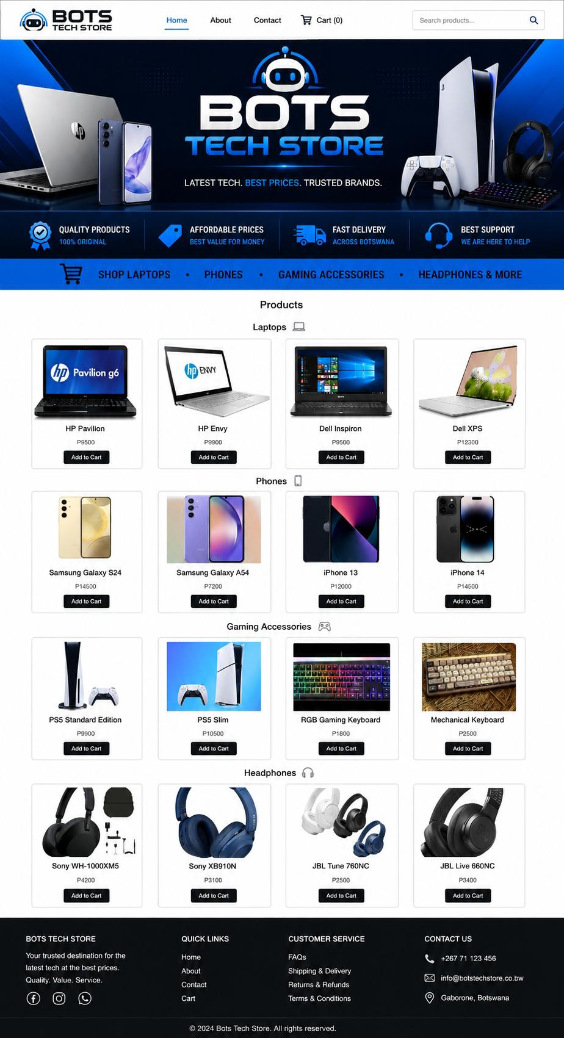

The website uses a clean and modern layout. All pages follow a consistent structure to improve usability and user experience.
Header Section
Company logo
Navigation menu
Search bar
Banner Section
Promotional banner
Featured products
Company slogan
Main Content Area
Product cards
Images
Prices
Descriptions
Add to Cart buttons
Sidebar (Optional)
Product categories
Footer Section

4. TECHNICAL BRIEF
Technologies Used
HTML5
HTML5 was used to create the structure of the website pages. It provides semantic tags which improve accessibility and organization.
CSS3
CSS3 was used to style the website and create:
Layouts
Colours
Responsive design
Typography
JavaScript
JavaScript was used to add interactivity such as:
Form validation
Shopping cart functionality
Button interactions
Dynamic content updates
Bootstrap Framework
Bootstrap was used to improve responsiveness and mobile compatibility.
Software Tools Used
Visual Studio Code: Writing and editing code
GitHub: Website hosting and version control
GitHub Pages: Publishing the website online
Google Chrome: Browser testing
Mozilla Firefox: Cross-browser testing

Canva: Creating banners and logos

5. QUALITY ASSURANCE
Quality assurance testing was conducted to ensure that the website functions properly across multiple devices and browsers.
Browser Compatibility Testing

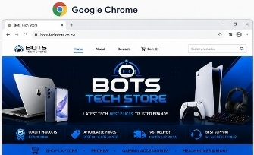
Google Chrome: Passed

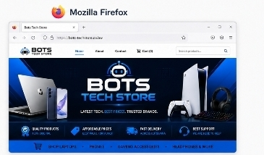
Mozilla Firefox: Passed

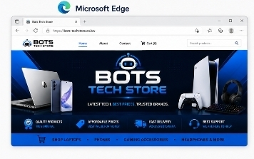
Microsoft Edge: Passed

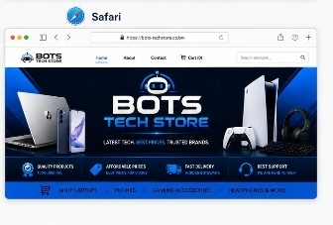
Safari: Passed

Test Description:
The website layout, navigation links, images and forms were tested on all browsers listed above. No broken links or layout issues were identified.
Mobile Device Testing
Android Smartphone: Passed
Tablet: Passed
Laptop: Passed

Images resized properly
Navigation adapted to small screens
Text remained readable
Buttons were clickable on touch
6. PUBLISHING & PROMOTION
Website Hosting
The website was hosted using GitHub Pages.
GitHub Repository Name: cse209-cell/Thomo209-WMD-Assignment
GitHub Pages Url: cse209-cell.github.io/Thomo209-WMD-Assignment/

8. FUTURE DEVELOPMENTS AND RECOMMENDATIONS

Future Improvements:
Add secure online payment systems
Add user login and registration
Add live chat support
Add product reviews and ratings by users
Improve search functionality
Integrate AI product recommendations
These improvements would increase customer engagement and improve user experience, which would increase the sales of products the store.
9. CONCLUSION
In conclusion, the Bots Tech Gadgets website successfully meets the objectives of the assignment by providing a responsive and modern e-commerce platform for technology products. The website was designed using HTML5, CSS3, JavaScript and Bootstrap while following proper website development processes.
The project demonstrates effective planning, information architecture, responsive design, quality assurance testing and GitHub deployment. The website also provides a strong foundation for future improvements and business growth.
Overall, the website delivers a professional online presence for Bots Tech Gadgets and improves accessibility for customers who wish to browse and purchase electronic products online.

